Computer Practical File Programme: Computer Science C++

Aim: To write Program to declare a structure to declare a complex number .Write a function to add, subtract, multiply and divide two complew numbers.

Source Code:

#include<iostream.h>

#include<process.h>

#include<conio.h>

struct complex

{

int x, y;

};

complex add(complex, complex);

complex add(complex a1, complex a2)

{

complex a3;

a3.x=a1.x+a2.x;

a3.y=a1.y+a2.y;

return(a3);

}

complex sub(complex, complex);

complex sub(complex a1, complex a2)

{

complex a3;

a3.x=a1.x-a2.x;

a3.y=a1.y-a2.y;

return(a3);

}

complex mul(complex, complex);

complex mul(complex a1, complex a2)

{

complex a3;

a3.x=((a1.x\*a2.x)-(a1.y\*a2.y));

a3.y=((a1.x\*a2.y)+(a2.x\*a1.y));

return(a3);

}

complex div(complex, complex);

complex div(complex a1, complex a2)

{

complex a3;

a3.x=((a1.x\*a2.y)+(a1.y\*a2.y))/((a2.x\*a2.x)+(a2.y\*a2.y));

a3.y=((a2.x\*a1.y)-(a1.x\*a2.y))/((a2.x\*a2.x)+(a2.y\*a2.y));

return(a3);

}

void main()

{

clrscr();

complex a1, a2;

int choice;

cout<<"Enter complex no 1\n";

cout<<"Enter real part of complex number 1 :";

cin>>a1.x;

cout<<"Enter imaginary part of complex number 1:";

cin>>a1.y;

cout<<"Enter complex no 2\n";

cout<<"Enter real part of complex number 2 : ";

cin>>a2.x;

cout<<"Enter imaginary part of complex 2 :";

cin>>a2.y;

cout<<"Action to be performed";

cout<<"\n1.Add"

<<"\n2.Subtract"

<<"\n3.Multiply"

<<"\n4.Divide"

<<"\nEnter choice ";

complex a3;

cin>>choice;

if(choice==1)

{

a3=add(a1,a2);

cout<<"The result is "<<a3.x<<"+"<<a3.y<<"i";

}

else if(choice==2)

{

a3=sub(a1,a2);

cout<<"The result is "<<a3.x<<"+"<<a3.y<<"i";

}

else if(choice==3)

{

a3=mul(a1,a2);

cout<<"The result is "<<a3.x<<"+"<<a3.y<<"i";

}

else if(choice==4)

{

a3=div(a1,a2);

cout<<"The result is "<<a3.x<<"+"<<a3.y<<"i";

}

else

exit(0);

getch();

}

Output:

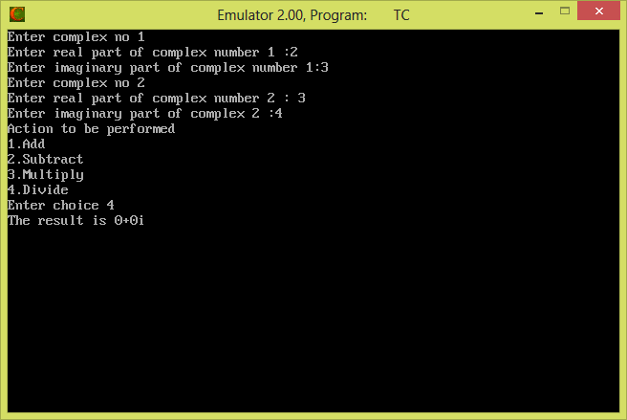

cout<<"Enter real part of complex number 1 :";

cin>>a1.x;

cout<<"Enter imaginary part of complex number 1:";

cin>>a1.y;

cout<<"Enter complex no 2\n";

cout<<"Enter real part of complex number 2 : ";

cin>>a2.x;

cout<<"Enter imaginary part of complex 2 :";

cin>>a2.y;

cout<<"Action to be performed";

cout<<"\n1.Add"

<<"\n2.Subtract"

<<"\n3.Multiply"

<<"\n4.Divide"

<<"\nEnter choice ";

complex a3;

cin>>choice;

if(choice==1)

{

a3=add(a1,a2);

cout<<"The result is "<<a3.x<<"+"<<a3.y<<"i";

}

else if(choice==2)

{

a3=sub(a1,a2);

cout<<"The result is "<<a3.x<<"+"<<a3.y<<"i";

}

else if(choice==3)

{

a3=mul(a1,a2);

cout<<"The result is "<<a3.x<<"+"<<a3.y<<"i";

}

else if(choice==4)

{

a3=div(a1,a2);

cout<<"The result is "<<a3.x<<"+"<<a3.y<<"i";

}

else

exit(0);

getch();

}